**PROJECT BASED LAB REPORT**

**On**

**BANK LOAN STATUS MANAGEMENT SYSTEM**

**Submitted in partial fulfilment of the**

**Requirements for the award of the Degree of**

**Bachelor of Technology**

**In**

**INFORMATION TECHNOLOGY**

**By**

**S.V.S.V.M.Praveen(21A31A1257)**

**Under the guidance of**

**D.kondababuB.Tech,M.tech.**



**DEPARTMENT OF INFORMATION TECHNOLOGY**

**PRAGATI ENGINEERING COLLEGE**

**DEPARTMENT OF INFORMATION TECHNOLOGY**



**CERTIFICATE**

This is to certify that this project based lab report entitled **“BANK LOAN STATUS MANAGEMENT** SYSTEM**”** is a bonafide work done by S.V.S.V.M.Praveen(21A31A1257) in partial fulfillment of the requirement for the award of degree in **BACHELOR OF TECHNOLOGY in INFORMATION TECHNOLOGY** during the academic year 2023-2024.

**Faculty in charge Head of the Department**

Mr.D.KondababuDr.D.Sirisha

**Mini-Project guide**

Mr.G.Satya Mohan Chowdary

**ACKNOWLEDGEMENT**

My sincere thanks to **Mr.D.Kondababu sir** in the Lab for his outstanding support throughout the project for the successful completion of the work

I express My gratitude to **,Dr.M.Umadevi,** Head of the Department for Information Technology for providing me with adequate facilities, ways and means by which we are able to complete this project work.

I would like to place on record the deep sense of gratitude to the honourable Director, **DR.K.Satyanarayana garu** for providing the necessary facilities to carry the concluded project work and especially my classmates and my parents for their support in the completion of our project work.

**S.V.S.V.M.PRAVEEN – 21A31A1257**

**CONTENTS**

1. Introduction 7
2. Process Description 8
3. Limitations of Existing system 9
4. Project Description 9
5. Hardware Description 10
6. Source code 11
7. Outputs 19
8. References 21

**Abstract:**

The objective behind developing employee loan management is to maintain loan types, employee loan details and salary details of the employee within an organization. It provides different types of loan based on designation and the loan payment details. Every organization has many employees, who are responsible for all the activities in that organization. These employees can manage different aspects of the organizational management issues, such as manufacturing, production, marketing etc. In this system the employee can view the available loans and amount based on the designation. All employees information and loan details can be stored in the centralized database. Now days technology as day by day increased if you check your bank loan status we can’t go the bank. We can stand your place to check your bank loan status by using the internet. The system provides the access to the customer to choose either Education or Home loan, also to view reports of all accounts present. This project is developed to nurture the needs of a user in a banking sector by embedding all the tasks of transactions taking place in a bank.

**1.INTRODUCTION**

**About Banking in India:**

A bank is a financial institution which accepts deposits, pays interest on pre-defined rates, clears checks, makes loans, and often acts as an intermediary in financial transactions. It also provides other financial services to its customers. Bank management governs various concerns associated with bank in order to maximize profits. The concerns broadly include liquidity management, asset management, liability management and capital management.

The existing banking structure in India, evolved over several decades, is elaborate and has been serving the credit and banking services needs of the economy. There are multiple layers in today's banking structure to cater to the specific and varied requirements of different customers and borrowers.

The banking structure played a major role in the mobilisation of savings and promoting economic development **Banking in India** in the modern sense originated in the last decades of the 18th century. The among the first banks were Bank of Hindustan, which established in 1770 and liquidated in 1829-32; and General Bank of India, established 1786 but failed in 1791.The largest bank, and the oldest still in existence, is the

[State Bank of India](http://en.wikipedia.org/wiki/State_Bank_of_India" \o "State Bank of India).

It originated as the [Bank of Calcutta](http://en.wikipedia.org/wiki/Bank_of_Calcutta)in June 1806. The Indian banking sector is broadly classified into

[scheduled banks](http://en.wikipedia.org/wiki/Scheduled_bank" \o "Scheduled bank) and non-scheduled banks. The scheduled banks are those which are included under the 2nd Schedule of the Reserve Bank of India Act, 1934. The scheduled banks are further classified into: nationalised banks;

[State Bank of India](http://en.wikipedia.org/wiki/State_Bank_of_India" \o "State Bank of India) and its associates;

[Regional Rural Banks](http://en.wikipedia.org/wiki/Regional_Rural_Bank" \o "Regional Rural Bank) (RRBs); foreign banks; and other Indian private sector banks. The term commercial banks refers to both scheduled and non-scheduled commercial banks which are regulated under the

[Banking Regulation Act, 1949](http://en.wikipedia.org/wiki/Banking_Regulation_Act,_1949" \o "Banking Regulation Act, 1949).

**2.FUNCTIONAL REQUIREMENTS:**

  In this project we are calculating two types of loans in bank process they are

1.Education Loan

2.Home Loan

3. Search

**1 = >**

For education loan we are taking the details of the father to verify that the income is more than 1lakh. If his income is above 1 lakh then we will take the details of the student like name, college name, course ,and any security details. Then loan amount and ten calculate the interest.

**2 = >**

For home loan taking the details and income, if he is eligible loan will be issued.

**3 = >**

To know the status of the account then select Search and enter the keyword to search either in Home or Education loan.

**SYSTEM SPECIFICATION**

The BANKING SYSTEM is a very vast system to be handled manually and its computerization will prove to be of great help to both the employees and the customers.

**SECURITY:-**

From security point of view, authentication will be done by password checking. If correct password has been entered by the user, the user will get further access to the system, otherwise he will have to re-enter the password. The facility to change the password has also been provided but for that the user will have to first enter the old password. The password can be four characters long.

**3. LIMITATIONS OF EXISTING SYSTEM: -**

**Data and redundancy:**

It means that same data fields appear in many different files and often in different formats.In manual , it poses quite a big problem because the data has to be maintained in large volumes but in our system, this problem can be overcome by providing the condition that if the data entered is duplicate, it will not be entered, otherwise, updating will take place.

**Dfficulty in accessing the data:**

In manual system, searching information is time consuming but in our system, any information can be accessed by providing the primary key.

**Unsatisfactory security measures:**

In manual system, no security measures were provided but in this System, password security has been provided. The person can access the system by providing the correct password otherwise he is denied the access.

The objective of banking system is to give structural design to banking system. The project provides Functionality and flexibility to banking system such that one can operate that system easily and efficiently. This project also provides a complete set of solutions for some common and specific are as of work in the banks.

**4. PROJECT DESCRIPTION:**

1. **Searching of the account is so easy:**

It is easy to search for the wished account by just typing the account number. Then it just shows all the details about that account like name and current balance in that account.

1. **Reduce the possibility to make mistake:**

Due to excessive amount of work the employers tend to do mistakes by manual form. Here the chance of mistake is minimum.

1. **Calculating EMI:** The overall method is very easy and based on few steps. No huge amount of knowledge is needed to complete the task.

**5.HARDWARE DESCRIPTION:**

**Definition of Hardware:**

Computer hardware is the collection of physical elements that constitutes a computer system. Computer hardware refers to the physical parts or components of a computer such as the monitor, mouse, keyboard, computer data storage, hard drive disk (HDD), system unit (graphic cards, sound cards, memory, motherboard and chips), etc. all of which are physical objects that can be touched.[1] In contrast, software is instructions that can be stored and run by hardware.

**Minimum Hardware Requirements for our Program:**

* PROCESSOR : Pentium IV processor or Greater
* RAM : 1 Giga Byte (GB) or Greater
* HARD DISK  : 100 Giga Byte (GB) or Greater

Keyboard & Mouse

MONITOR : Colour (For Best Result)

Printer

**Definition of software:**

Computer software, or just software, is any set of machine-readable instructions that directs a computer's processor to perform specific operations. The term is used to contrast with computer hardware, the physical objects (processor and related devices) that carry out the instructions. Computer hardware and software require each other and neither can be realistically used without the other.

**Minimum Software Requirements:**

* Operating System : Windows 2000/ xp /7

Java and NetBeans

**6. NON-FUNCTIONAL REQUIREMENTS**

**INTERFACE:**

An interface is a reference type in Java. It is similar to class. It is a collection of abstract methods. A class implements an interface, thereby inheriting the abstract methods of the interface. Along with abstract methods, an interface may also contain constants, default methods, static methods, and nested types.

**INHERITANCE :**

Inheritance in java is a mechanism in which one object acquires all the properties and behaviors of parent object. The idea behind inheritance in java is that you can create newclasses that are built upon existing classes.

**ABSTRACT CLASS:**

A class that is declared with abstract keyword, is known as abstract class in java. It can have abstract and non-abstract methods (method with body). **Abstraction** is a process of hiding the implementation details and showing only functionality to the user.

Another way, it shows only important things to the user and hides the internal details for example sending sms, you just type the text and send the message. You don't know the internal processing about the message delivery.

**ABSTRACT METHOD:**

An abstract method is a method that is declared, but contains no implementation. Abstract classes may not be instantiated, and require subclasses to provide implementations for the abstract methods. Let's look at an example of an **abstract** class, and an abstract method.

**STATIC KEYWORD:**

All instances share the same copy of the variable. A class variable can be accessed directly with the class, without the need to create a instance.

**EXCEPTION HANDLING:**

An exception (or exceptional event) is a problem that arises during the execution of a program. When an exception occurs the normal flow of the program is disrupted and the program/Application terminates abnormally, which is not recommended, therefore, these exceptions are to be handled.

**7.Source Code:**

import java.text.NumberFormat;

import java.util.Scanner;

import java.io.*;

interface EMI{

double calculateMonthlyPayment(int loanAmount, int termInYears, double interestRate);

}

class payment implements EMI{

public double calculateMonthlyPayment(int loanAmount, int termInYears, double interestRate)

{

interestRate /= 100.0;

double monthlyRate = interestRate / 12.0;

int termInMonths = termInYears * 12;

double monthlyPayment =(loanAmount*monthlyRate) /(1-Math.pow(1+monthlyRate, -termInMonths));

return monthlyPayment;

}

}

class Menu{

int ab;

void display(){

System.out.println("\t\t========================================");

System.out.println("\t\t\tWelcome to SBI loan");

System.out.println("\t\t=======================================");

System.out.println("\t\t 1.Education Loan");

System.out.println("\t\t2.Home Loan");

System.out.println("\t\t3.Search");

System.out.println("\t\t4. Exit");

System.out.println("\n\n Enter the type of loan 1 or 2 or 3:");

Scanner in=new Scanner(System.in);

ab=in.nextInt();

}

}

class loan extends Menu{

payment p=new payment();

void Eduloan() {

try{

Scanner in=new Scanner(System.in);

File file=new File("Eduloan.txt");

// if file doesnt exists, then create it

if (!file.exists()) {

file.createNewFile();

}

FileWriter fw = new FileWriter("Eduloan.txt",true);

BufferedWriter bw = new BufferedWriter(fw);

System.out.println("Enter father name:");

String fname=in.next();

System.out.println("Enter father bank account nuumber:");

String facc=in.next();

System.out.println("Enter father income per annum:");

double fin=in.nextDouble();

if(fin>=100000)

{

System.out.println("Enter name:");

String sname=in.next();

System.out.println("Enter aadhar card no:");

String saad=in.next();

System.out.println("Enter college details:");

String sc=in.next();

System.out.print("Enter loan amount: ");

int loanAmount =in.nextInt();

System.out.print("Enter loan term (in years): ");

int termInYears = in.nextInt();

double interestRate =20;

double monthlyPayment =p.calculateMonthlyPayment(loanAmount, termInYears, interestRate);

NumberFormat currencyFormat =NumberFormat.getCurrencyInstance();

NumberFormat interestFormat =NumberFormat.getPercentInstance();

System.out.println("Loan Amount: "+currencyFormat.format(loanAmount));

System.out.println("Loan Term: "+termInYears+" years");

System.out.println("Interest Rate: "+interestFormat.format(interestRate));

System.out.println("Monthly Payment: "+currencyFormat.format(monthlyPayment));

bw.write("Father name:"+fname+" ");

bw.write("Father acc No."+facc+" ");

bw.write("Student name:"+sname+" "+"Student aadhaar:"+saad+" ");

bw.write("Term in years:"+termInYears+" ");

bw.write("Loan amount:"+currencyFormat.format(loanAmount)+" ");

bw.write("Interest rate:"+interestFormat.format(interestRate)+" ");

bw.write("EMI:"+currencyFormat.format(monthlyPayment)+" ");

bw.newLine();

}

else

{System.out.println("You are not eligible for loan");}

bw.close();

}

catch (IOException e) {

e.printStackTrace();

}

}

void Homeloan(){

try{

Scanner in=new Scanner(System.in);

File file1=new File("Home Loan.txt");

// if file doesnt exists, then create it

if (!file1.exists()) {

file1.createNewFile();

}

FileWriter fwh = new FileWriter("Home Loan.txt",true);

BufferedWriter bwh = new BufferedWriter(fwh);

System.out.println("Enter Applicants name:");

String bs=in.next();

System.out.println("Enter bank account nuumber:");

String br=in.next();

System.out.println("Enter aadhar card no:");

String bc=in.next();

System.out.println("Enter security for loan(eg;land documents):");

String o=in.next();

System.out.println("Enter your income per annum:") ;

double fd=in.nextDouble();

if(fd>=100000)

{

System.out.print("Enter loan amount: ");

int loanAmount =in.nextInt();

System.out.print("Enter loan term (in years): ");

int termInYears = in.nextInt();

double interestRate =15;

double monthlyPayment = p.calculateMonthlyPayment(loanAmount, termInYears, interestRate);

NumberFormat currencyFormat =NumberFormat.getCurrencyInstance();

NumberFormat interestFormat =NumberFormat.getPercentInstance();

System.out.println("Loan Amount: "+ currencyFormat.format(loanAmount));

System.out.println("Loan Term: "+ termInYears+" years");

System.out.println("Interest Rate: "+interestFormat.format(interestRate));

System.out.println("Monthly Payment: "+ currencyFormat.format(monthlyPayment));

bwh.write("Applicant name:"+bs+" "+"Bank acc no:"+br+" "+"income:"+fd+" ");

bwh.write("Loan amount:"+currencyFormat.format(loanAmount)+" ");

bwh.write("Interest rate:"+interestFormat.format(interestRate)+" ");

bwh.write("EMI:"+currencyFormat.format(monthlyPayment)+" ");

bwh.newLine();

}

else

{System.out.println("You are not eligible for loan");}

bwh.close();}

catch (IOException e) {

e.printStackTrace();

}

}

void searchedu()throws Exception{

int i=0;

Scanner in =new Scanner(System.in);

System.out.println("enter the name you want to search:");

String name= in.next();

File file=new File("Eduloan.txt");

Scanner sc = new Scanner(file);

while (sc.hasNextLine()) {

String lineFromFile = sc.nextLine();

if(lineFromFile.contains(name)) {

System.out.println("I found " +name+ " in Data base");

System.out.println(lineFromFile);

i=1;

break;

}

}

if(i==0){

System.out.println("File not found");

}

}

void searchhome()throws Exception{

int i=0;

Scanner in =new Scanner(System.in);

System.out.println("enter the name you want to search:");

String name= in.next();

File file=new File("Home Loan.txt");

Scanner sc = new Scanner(file);

while (sc.hasNextLine()) {

String lineFromFile = sc.nextLine();

if(lineFromFile.contains(name)) {

System.out.println("I found " +name+ " in Data base");

System.out.println(lineFromFile);

i=1;

break;

}

}

if(i==0){

System.out.println("File not found");

}

}

}

public class Bankloan

{

public static void main(String[] args)throws Exception

{ Scanner sc = new Scanner(System.in);

loan l = new loan();

while(true){

l.display();

int ch = l.ab;

switch(ch){

case 1: l.Eduloan();

break;

case 2: l.Homeloan();

break;

case 4: System.exit(0);

case 3: System.out.println("GET THE STATUS \n 1.Education loan \n2.Home loan");

int ch1=sc.nextInt();

if(ch1==1)

l.searchedu();

else

l.searchhome();

break;

default: System.out.println("Wrong choice");

} } } }

**7.Outputs:**

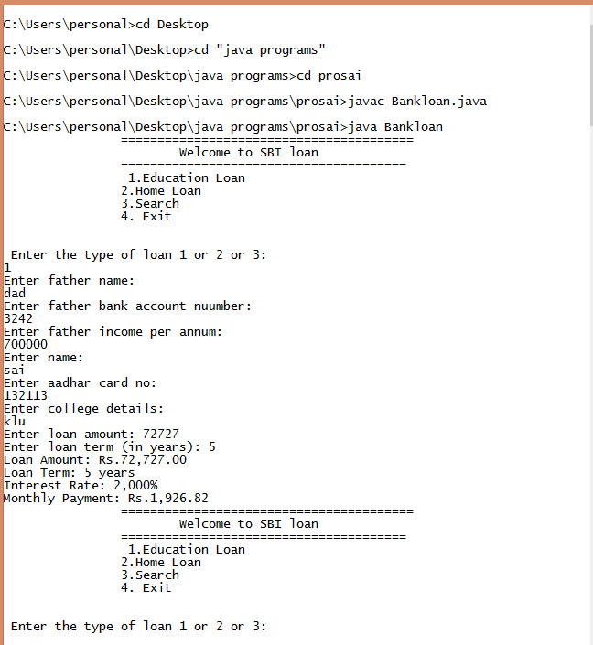

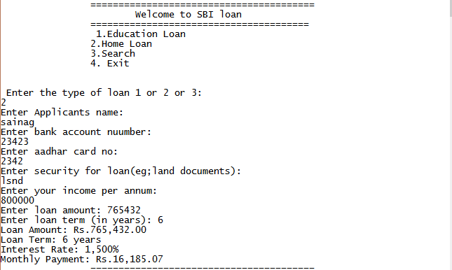

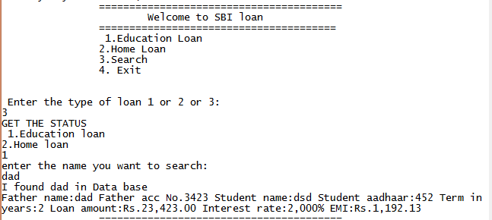

**8.References:**

* <http://www.freestudentprojects.com/studentprojectreport/projectreport/loan-management-system/>
* <http://1000projects.org/education-loan-management-system-project-with-source-code.html>
* <http://www.codingparks.com/loan-management-system-final-year-project/>
* http://1000projects.org/education-loan-management-system-project-with-source-code.html